EXPERIMENT – 14
House Price Prediction using Machine Learning Algorithm
AIM
To implement a House Price Prediction model using an appropriate machine learning algorithm in Python.
APPARATUS REQUIRED
- Google Colab
- Python 3.x
- NumPy
- Pandas
- Scikit-learn
- Matplotlib
ALGORITHM
- Start the program.
- Import the required Python libraries.
- Create or load the house price dataset.
- Preprocess the dataset.
- Select the input features and target variable.
- Split the dataset into training and testing data.
- Create a suitable machine learning regression model.
- Train the model using the training data.
- Predict the house prices for the test data.
- Evaluate the performance of the model.
- Display the predicted results.
- Stop the program.

PROGRAM
# Experiment 14: House Price Prediction

# Import required libraries
import numpy as np
import pandas as pd
import matplotlib.pyplot as plt

from sklearn.model_selection import train_test_split
from sklearn.linear_model import LinearRegression
from sklearn.metrics import mean_squared_error, r2_score

# Create sample house price dataset
data = {
"Area": [800, 1000, 1200, 1500, 1800,
2000, 2200, 2500, 2800, 3000],
"Bedrooms": [2, 2, 3, 3, 3,
4, 4, 4, 5, 5],
"Bathrooms": [1, 2, 2, 2, 3,
3, 3, 4, 4, 4],
"Price": [2500000, 3000000, 3600000, 4500000, 5400000,
6200000, 6800000, 7600000, 8500000, 9500000]
}
df = pd.DataFrame(data)

# Separate input features and target variable
X = df[["Area", "Bedrooms", "Bathrooms"]]
y = df["Price"]

# Split dataset into training and testing data
X_train, X_test, y_train, y_test = train_test_split(
X, y, test_size=0.2, random_state=42
)
# Create Linear Regression model
model = LinearRegression()
# Train the model
model.fit(X_train, y_train)
# Predict house prices
y_pred = model.predict(X_test)
# Display actual and predicted prices
print("Actual House Prices:")
print(y_test.values)
print("\nPredicted House Prices:")
print(y_pred)
# Evaluate the model
mse = mean_squared_error(y_test, y_pred)
r2 = r2_score(y_test, y_pred)
print("\nMean Squared Error:", mse)
print("R2 Score:", r2)
# Plot actual vs predicted prices
plt.scatter(y_test, y_pred)
plt.xlabel("Actual Price")
plt.ylabel("Predicted Price")
plt.title("House Price Prediction")
plt.show()
OUTPUT
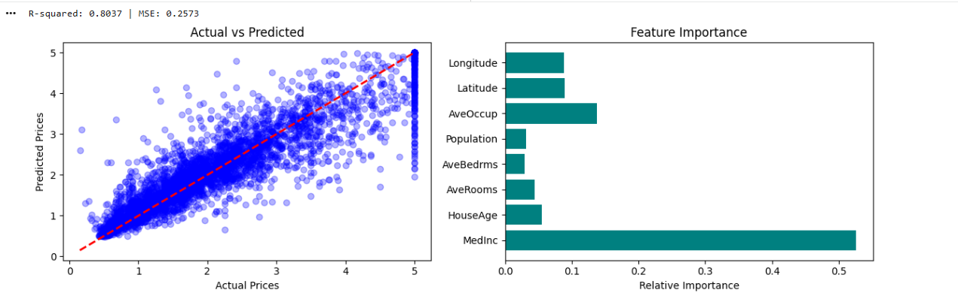
RESULT
Thus, the House Price Prediction model was successfully implemented using Python in Google Colab, and the house prices were predicted using the machine learning algorithm.

